User Acceptance Testing (UAT) Template
Date | 05 October 2026
Team ID | SWTID-2026-4248
Project Name | LearnMate AI StudyBuddy
Maximum Marks

Project Overview:
Project Name: LearnMate AI StudyBuddy
Project Description: AI-powered learning backend (Node.js, Express.js, MongoDB, JWT) that lets students upload study material and uses Google Gemini (gemini-3.5-flash-lite) to generate summaries, flashcards, quizzes and personalised study plans, with admin management.
Project Version: 1.0.0
Testing Period: 28 September 2026 to 05 October 2026
Testing Scope:
Features: user registration and login (JWT), role-based access, study material upload / list / view / delete, AI summary, AI flashcards, AI quiz, AI study plan, admin user management and statistics.
User stories / requirements tested: USN-1 to USN-22 (FR-1 to FR-8) – primarily USN-1, USN-3, USN-8, USN-14, USN-15, USN-16 and USN-17 verified with Postman screenshots.
Testing Environment:
URL/Location: http://localhost:5000 (local Node.js server; API tested with Postman in VS Code)
Credentials (if required): test accounts created through POST /api/auth/register (e.g. admin2@example.com); JWT Bearer token returned by login is used for protected APIs.
Test Cases:
Test Case ID | Test Scenario | Test Steps | Expected Result | Actual Result | Pass/Fail
TC-001 | Register a new user (POST /api/auth/register) | 1. Open Postman  2. POST to /api/auth/register  3. Send JSON body with name, email, password, role | HTTP 201 Created with message "Registered successfully", access and refresh tokens | HTTP 201 Created in 149 ms; tokens returned (Screenshot 1) | Pass
TC-002 | Login with valid credentials (POST /api/auth/login) | 1. POST to /api/auth/login  2. Send email and password as JSON | HTTP 200 with message "Logged in" and JWT tokens | HTTP 200 OK in 123 ms; tokens returned (Screenshot 2) | Pass
TC-003 | Upload study material (POST /api/materials/upload) | 1. Add Bearer token  2. Choose form-data with file (Nodejs.txt) and title  3. Send | HTTP 201 with message "Material uploaded" and stored material | HTTP 201 Created in 37 ms; material saved (Screenshot 3) | Pass
TC-004 | Generate AI summary (POST /api/materials/:id/summarize) | 1. Use material id from TC-003  2. POST to /summarize with token | HTTP 200 with a concise summary generated by Gemini | HTTP 200 OK in 2.57 s; summary returned (Screenshot 4) | Pass
TC-005 | Generate AI flashcards (POST /api/materials/:id/flashcards) | 1. Use a material id  2. POST to /flashcards with token | HTTP 200 with a JSON list of question/answer flashcards | HTTP 200 OK in 1.99 s; flashcards returned (Screenshot 5) | Pass
TC-006 | Generate AI quiz (POST /api/materials/:id/quiz) | 1. Use a material id  2. POST to /quiz with token | HTTP 200 with multiple-choice questions, options and answers | HTTP 200 OK in 15.72 s; quiz returned (Screenshot 6) | Pass
TC-007 | Generate AI study plan (POST /api/materials/:id/study-plan) | 1. Use a material id  2. POST to /study-plan with token (goal, hoursPerDay, days optional) | HTTP 200 with a day-by-day personalised study plan | HTTP 200 OK in 26.16 s; 7-day plan returned (Screenshot 7) | Pass
TC-008 | Login with wrong password (negative) | 1. POST to /api/auth/login with wrong password | HTTP 401 "Invalid credentials" | Not yet executed | Pending
TC-009 | Access protected route without token (negative) | 1. GET /api/materials without Authorization header | HTTP 401 "Not authenticated" | Not yet executed | Pending
TC-010 | Upload unsupported file type (negative) | 1. Upload a .jpg file to /api/materials/upload | Request rejected: only .txt, .md and .pdf allowed | Not yet executed | Pending
TC-011 | Student accesses admin route (negative) | 1. Log in as student  2. GET /api/admin/users | HTTP 403 "Admins only" | Not yet executed | Pending
Test Evidence (Postman screenshots):
Screenshot 1 – TC-001: POST /api/auth/register (201 Created)
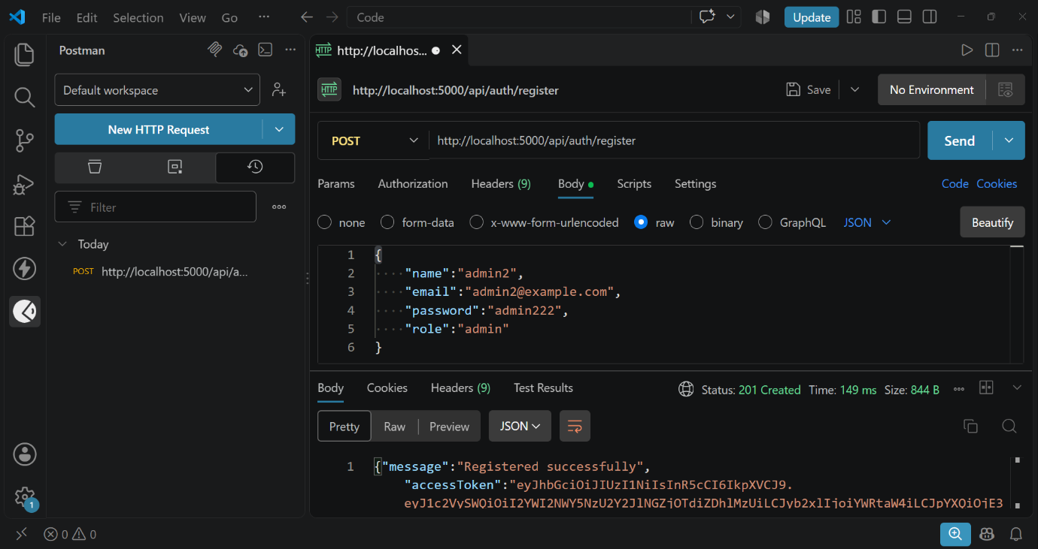
Screenshot 2 – TC-002: POST /api/auth/login (200 OK)
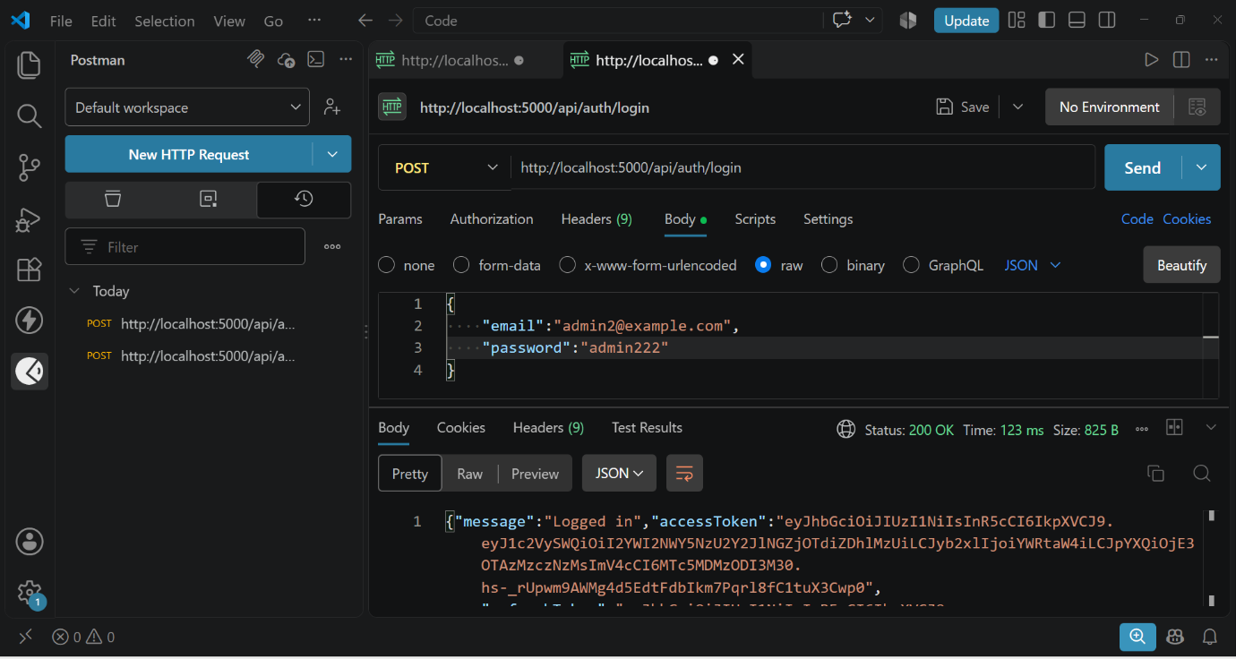
Screenshot 3 – TC-003: POST /api/materials/upload (201 Created)
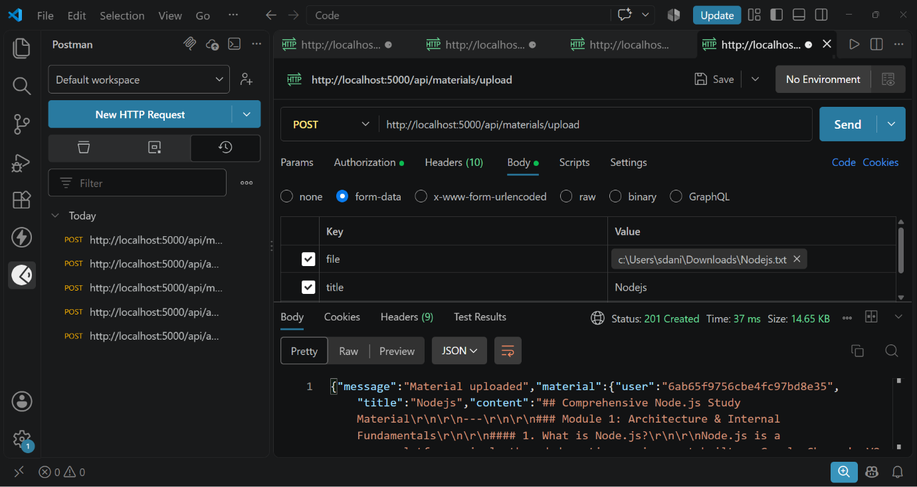
Screenshot 4 – TC-004: POST /api/materials/:id/summarize (200 OK)
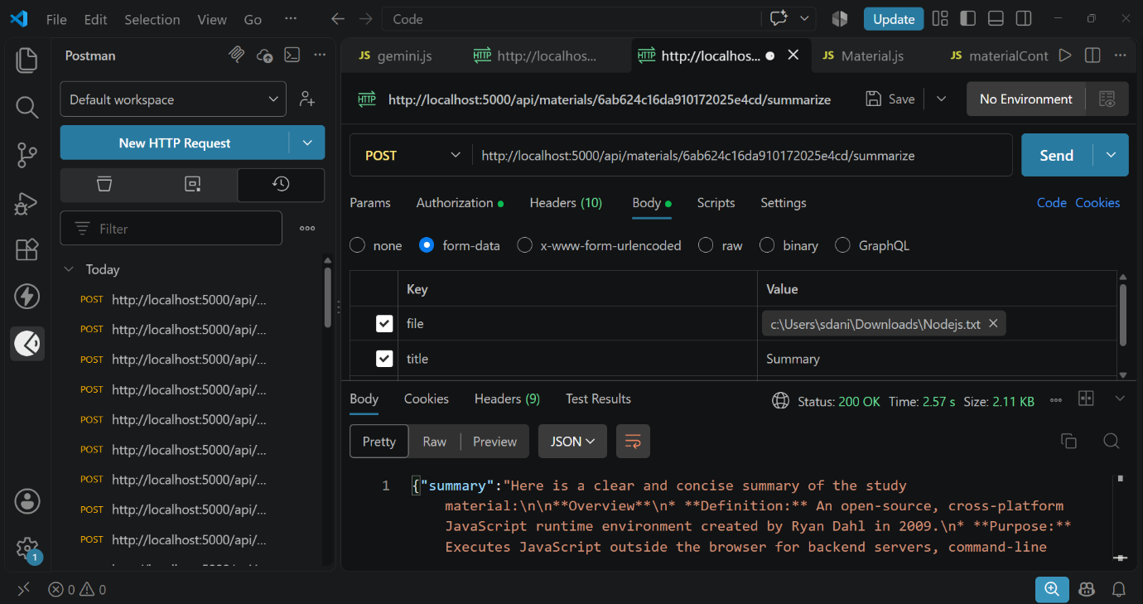
Screenshot 5 – TC-005: POST /api/materials/:id/flashcards (200 OK)
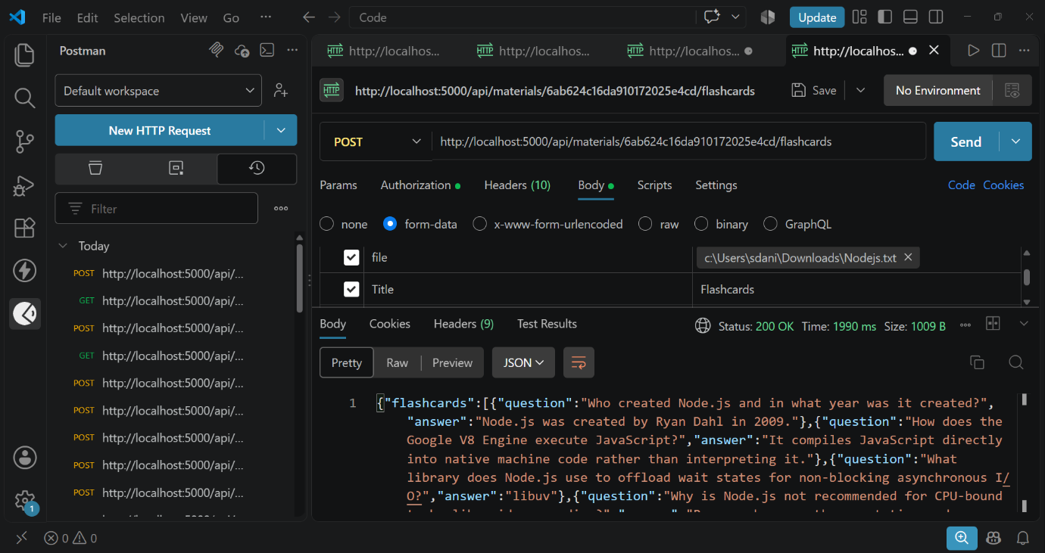
Screenshot 6 – TC-006: POST /api/materials/:id/quiz (200 OK)
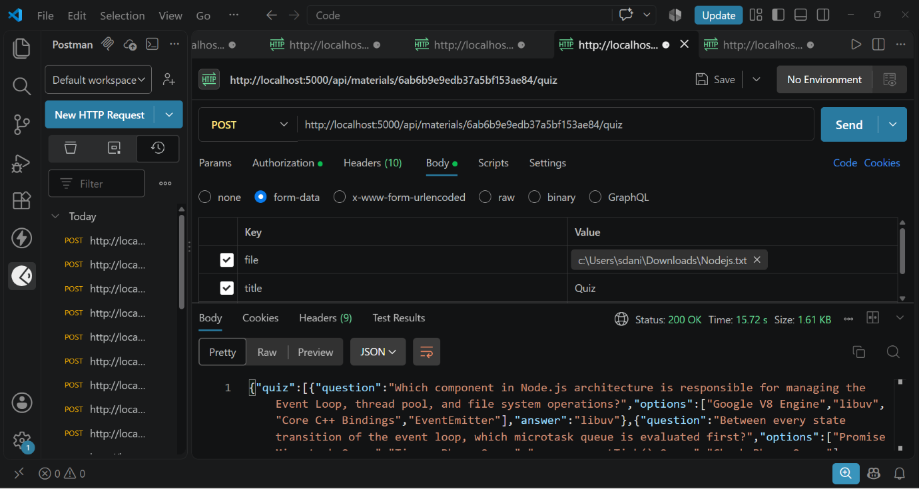
Screenshot 7 – TC-007: POST /api/materials/:id/study-plan (200 OK)
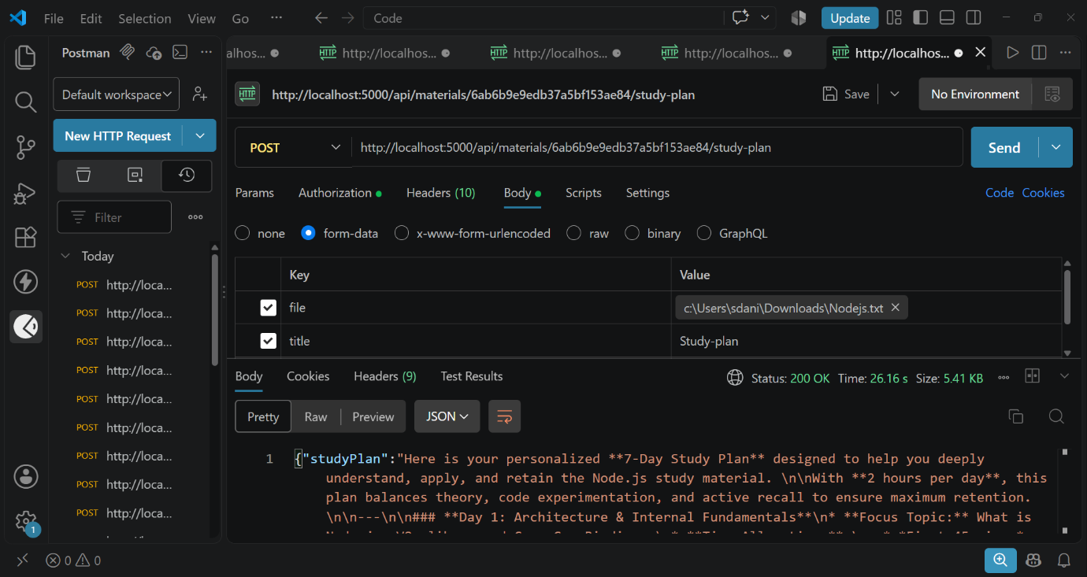

Bug Tracking:
Bug ID | Bug Description | Steps to reproduce | Severity | Status | Additional feedback
BG-001 | Any user can register with role "admin" because the role is read from the request body | 1. POST /api/auth/register  2. Send role: "admin"  3. Admin token is issued | High | Open | Restrict admin creation to a seed script or admin-only endpoint (found in code review)
BG-002 | npm start runs "nodemon server.js" but the entry file is index.js | 1. Run npm start  2. Server fails to start | Medium | Open | Change the start script to nodemon index.js
BG-003 | AI endpoints (summarize, flashcards, quiz, study-plan) do not check that the material belongs to the requesting user | 1. Log in as user B  2. Call /summarize with user A's material id | High | Open | Add the same ownership check used in getMaterial
BG-004 | Flashcard/quiz generation fails if Gemini returns text that is not valid JSON | 1. Call /flashcards or /quiz  2. JSON.parse throws on malformed output | Medium | Open | Wrap parsing in try/catch and retry or return a friendly error
BG-005 | README and package description still mention Gemini 2.5 Flash while the code uses gemini-3.5-flash-lite | 1. Compare README with src/utils/gemini.js | Low | Open | Update README and package.json description

Sign-off:
Tester Name: Vinu N
Date: 05 October 2026
Signature: ______________________
Notes:
- Ensure that all test cases cover both positive and negative scenarios.
- Encourage testers to provide detailed feedback, including any suggestions for improvement.
- Bug tracking should include details such as severity, status, and steps to reproduce.
- Obtain sign-off from both the project manager and product owner before proceeding with deployment.

